DEVOPS TASK- 2

1. Installation of Docker:

# CODE :

sudo apt install docker.io Docker –version

sudo systemctl start docker sudo systemctl enable docker sudo systemctl status docker

# SCREENSHOT:

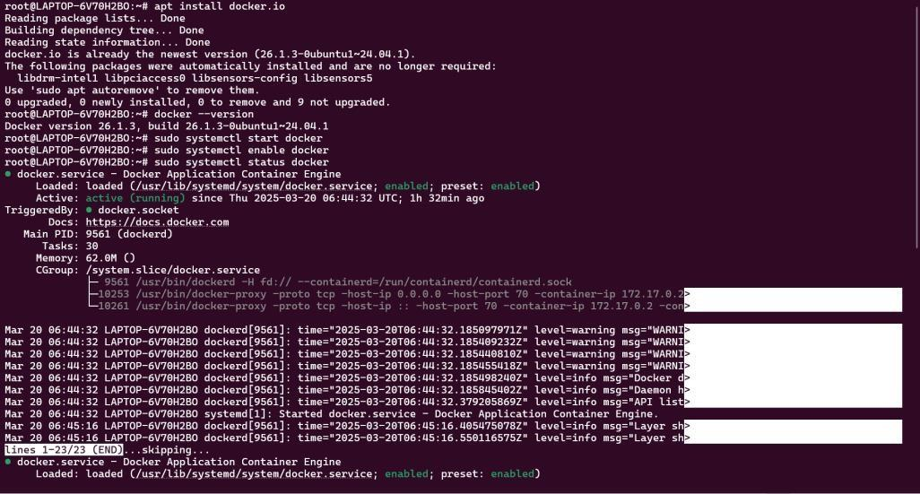

1. Fork a copy of a GitHub repo which contains the necessary files which will result in the clone of that repo in our own repository

# SCREENSHOT :

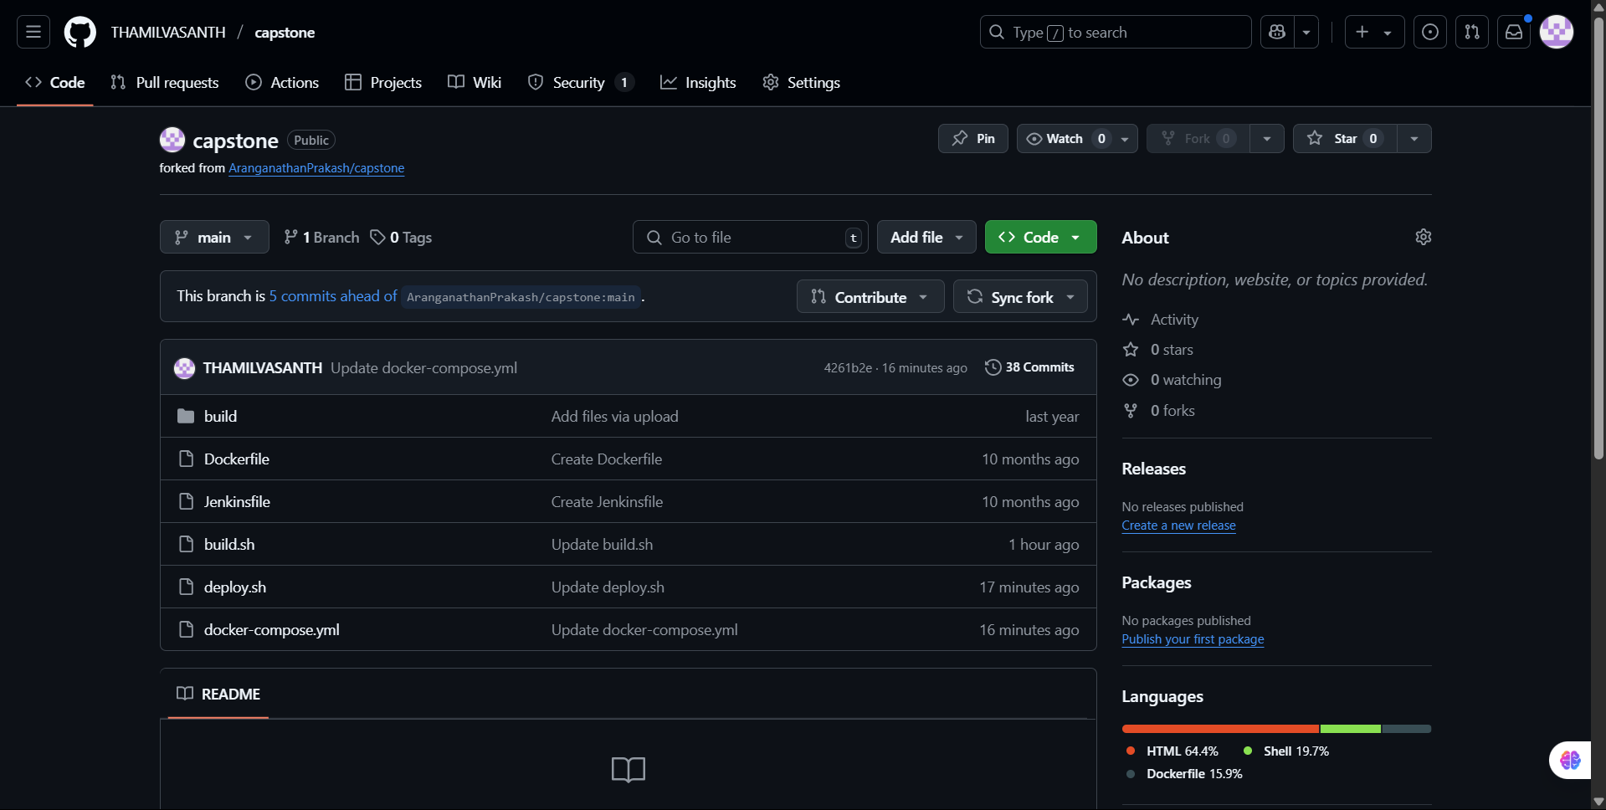

1. Then change the token and repo name of the docker Hub in the deploy.sh file which is in our repository.

# SCREENSHOT :

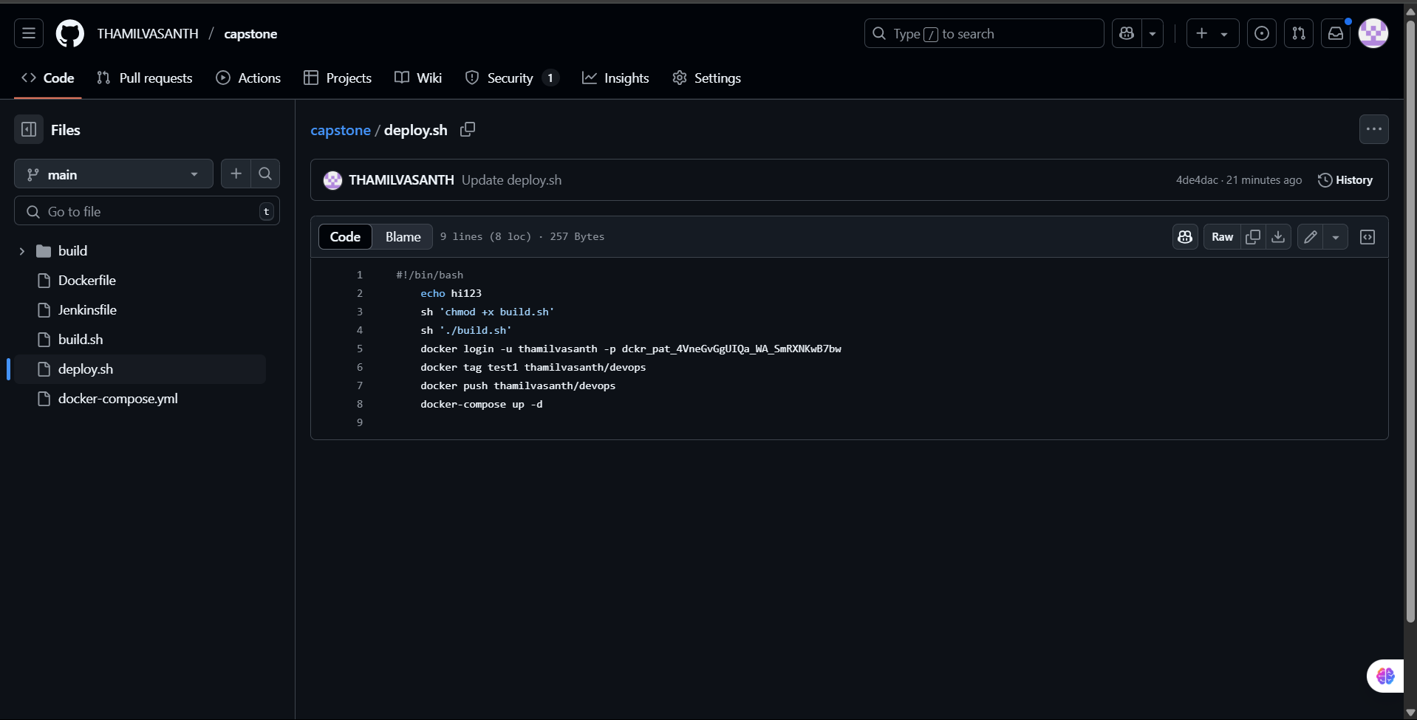

1. Then copy the GitHub link of the repository and go to Jenkins.

# SCREENSHOT:

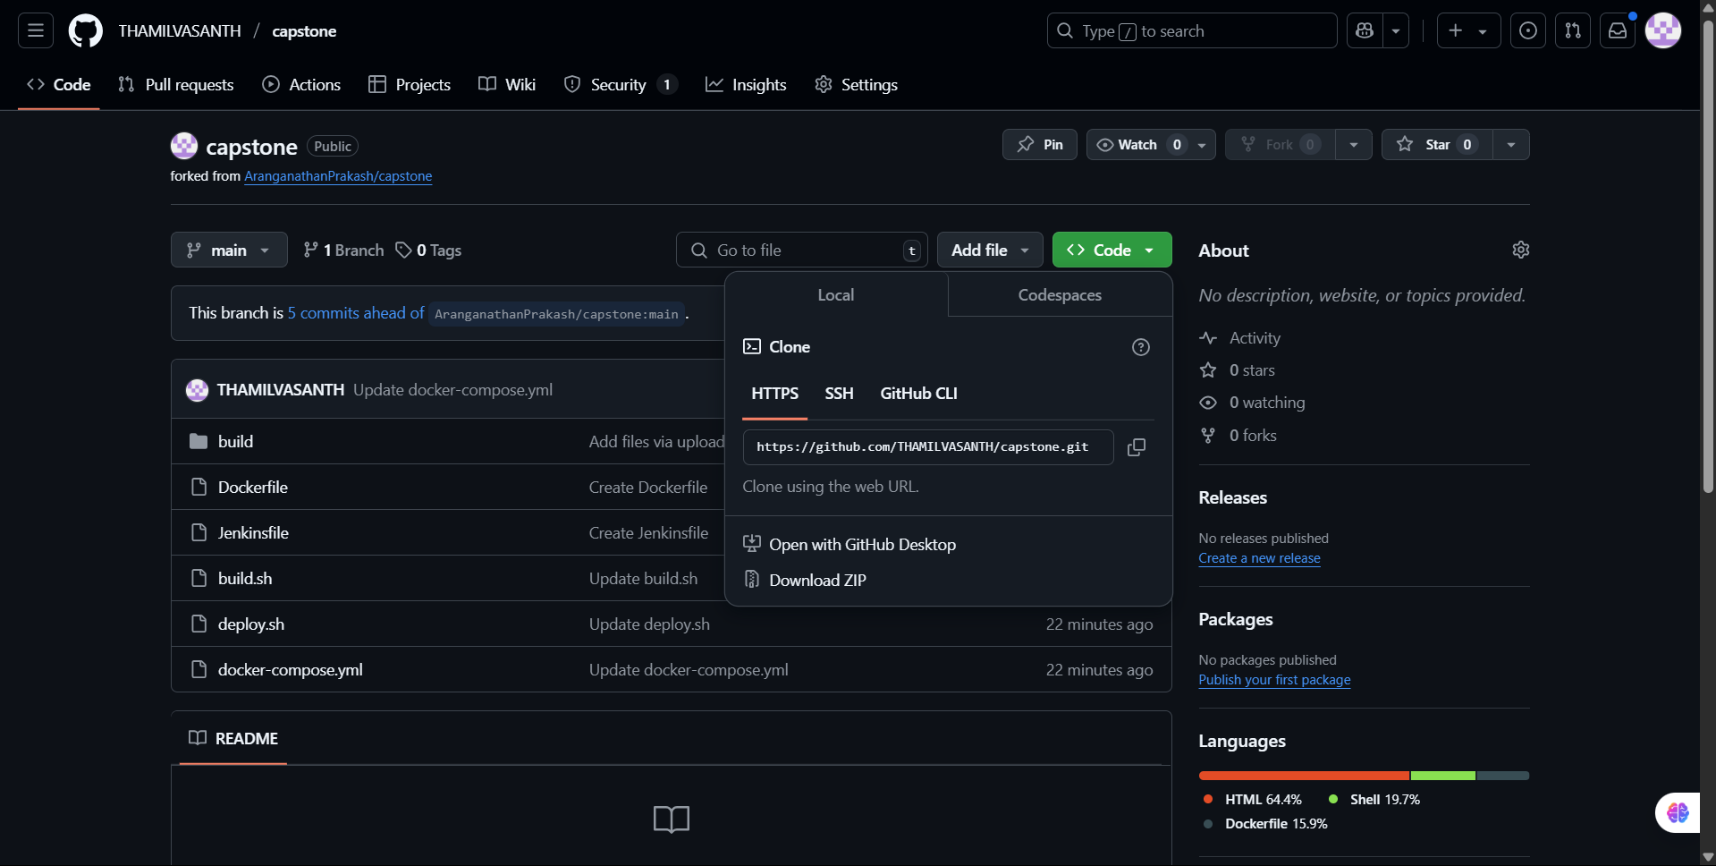

1. In Jenkins, create a new item (Job) with a type pipeline and add the copied GitHub url to it with the correct branch and Jenkinsfile.

# SCREENSHOT:

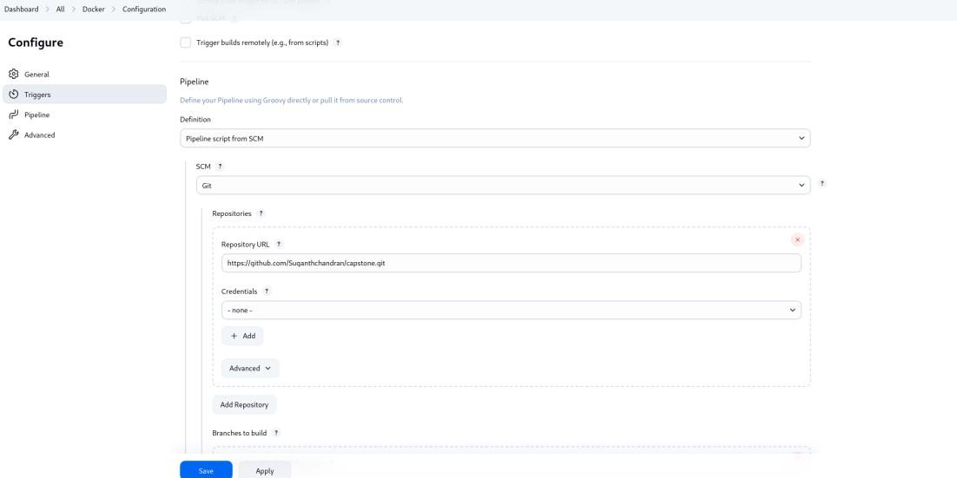

1. After Creating the job, build it and it will give the console output and the docker image will be created.

# SCREENSHOT:

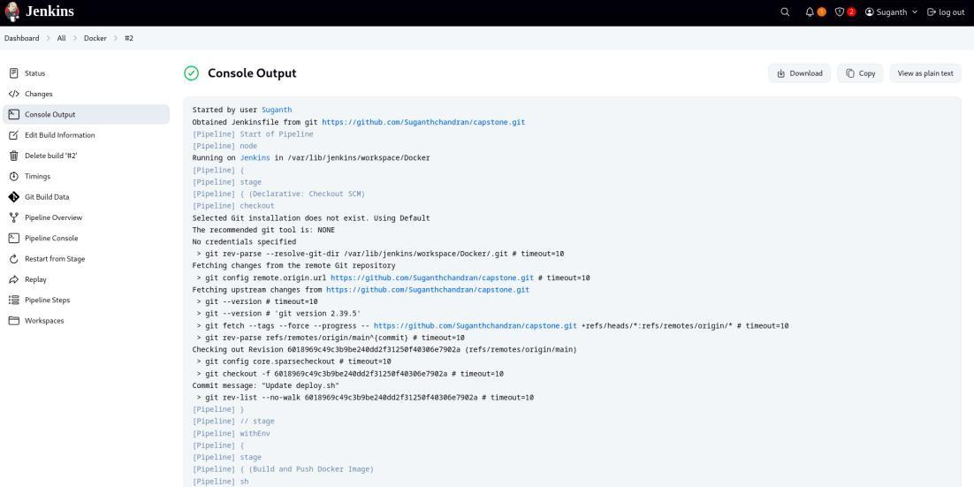

1. Now Built this docker image in the terminal with desired port number to it.

# CODE:

docker images

docker build –itd –p 70:80 test1

# SCREENSHOT:

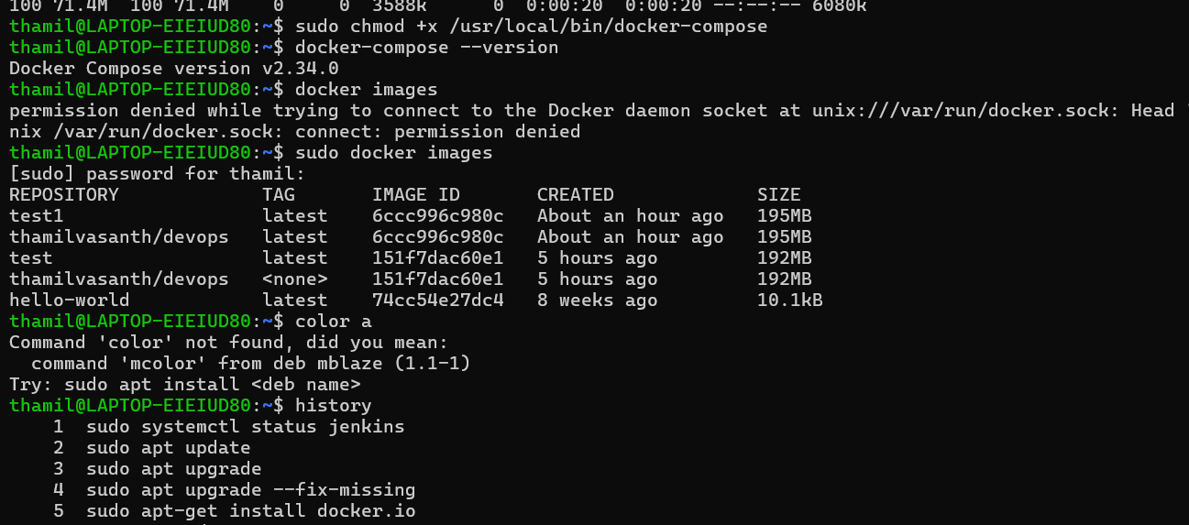

1. Go to the Browser and search for localhost:<PORT_NUMBER> and the respective application will be hosted.

**SCREENSHOT:**

